1.
For this assignment, watch one of the following movies. They are generally grouped by different leadership challenges; many can be found for free in the library, through Netflix or AmazonPrime, or through Hoopla.
After watching the movie, come back to this forum.
1. List the movie title and describe the plot and theme in two-three sentences.
2. Analyze the overall theme of the movie from the perspective of leadership. What elements of the movie reinforced the concepts you learned in this class? Provide two paragraphs of reflection
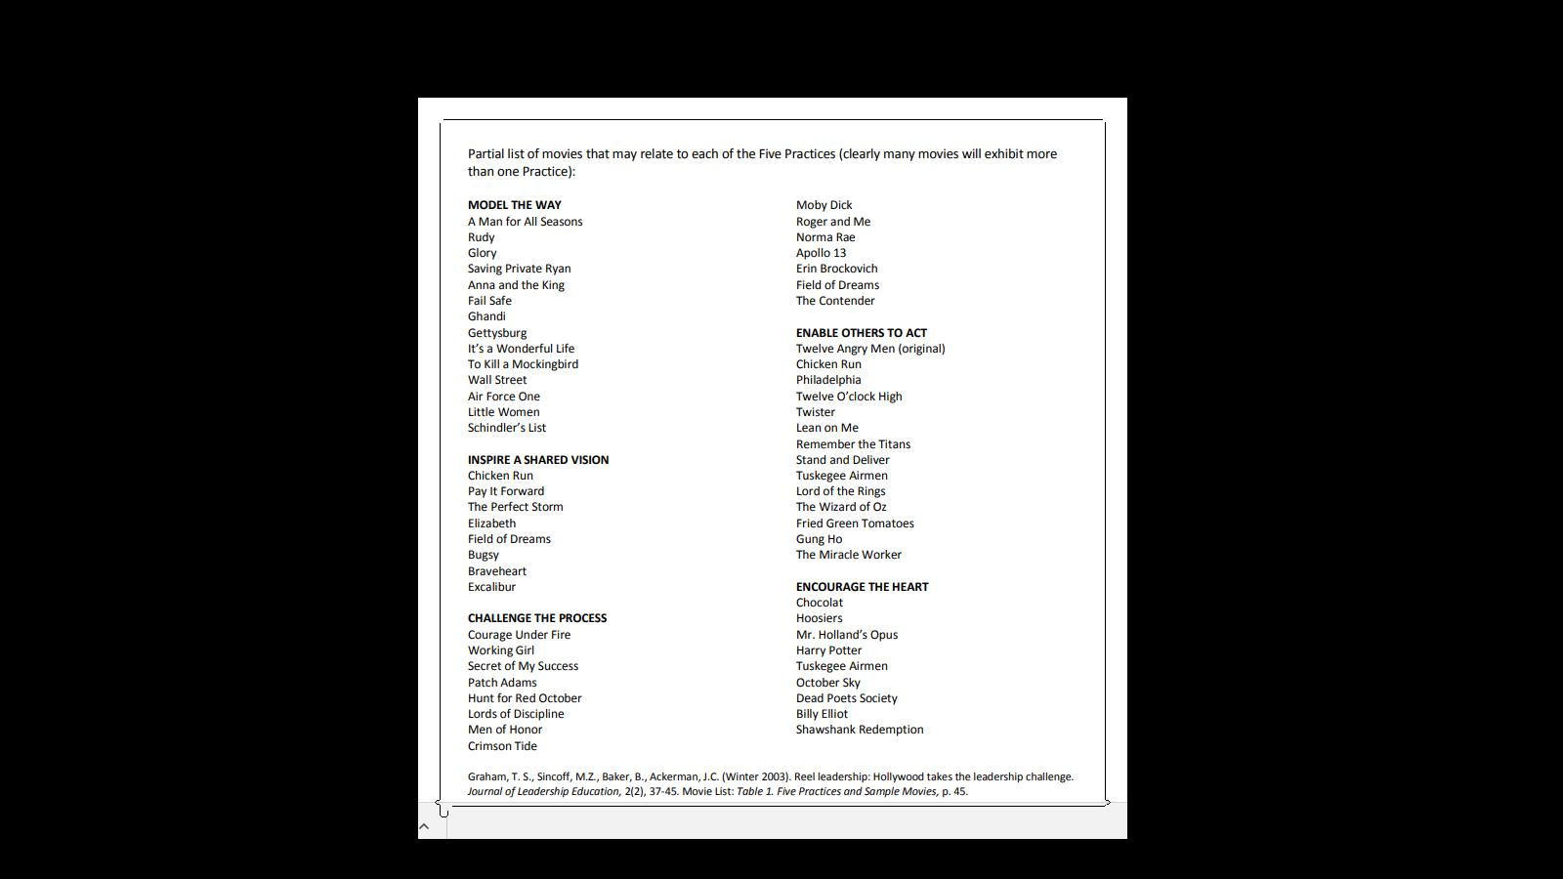

2. For this assignment write something like this paragraph see example please.( one parghraph)

Example:
According to the Strength-Based Leadership Assessment, my top five Clifton Strengths finder themes are: discipline, empathy, connectedness, positivity, and strategic. In my opinion, I agree with the results. I do see a little of each of the themes in my own personality. In executing, I am discipline, I am very rigid with myself when I have to get certain tasks or duties completed. In relationship building, I am empathetic with others, well connected, and always maintain positive attitude. Finally for strategic thinking, I carefully strategize to get certain tasks completed in a timely fashion.
I believe my strengths fit my job perfectly. I work closely with students to guide them through their Community College pathway. In addition, I conduct workshops and complete reports and deadline on the success of the program.
Or this one
Example:
Relationship Builder: Achiever, Includer, Positivity, Ideation, RelatorI
I was very surprised with my results. Based on my professional achievements, I was expecting to be an Executer or Strategic Thinker. Though my top 5 strengths are part of my personality, they aren't necessarily the strengths I primarily used to achieve goals. I'm wondering if the the strengths I did use were more out of necessity than what came naturally.
Being an Achiever made sense and is in line with the role I had in running a business. I love being busy as long as it's productive and serving a specific goal. Otherwise, I'd rather be off doing something fun! Being an Includer and Relator...hmm, I can see that in my personal relationships but not sure I'm that way at work. I am very empathetic (maybe too much) and I managed over 100 sales reps, who were often emotionally charged, so there's probably something to it.
As I was taking this test, I was wondering if it would be relevant, or if the results would be the same, if peers took the test and answered the questions about other peers. I would assume my perception of myself is different than what others see. It would be an interesting experiment. I might actually do that. If the results are the same, I should probably think about some career changes.

